STYLE US E-Commerce
Website - Project Report

Project Title: STYLE US – Online Fashion Store
Technologies Used: HTML, CSS, JavaScript, LocalStorage
Submitted by: Konkala Chandra Sekhar Reddy
Roll No / Reg No: 2401600039
Course / Department: MCA
College / University: KL University

Acknowledgment
I express my sincere gratitude to Datavalley for providing me with the opportunity to work on this internship project titled “STYLE US – Online Fashion Store.” This internship has given me valuable real-time experience in web development, enhancing my technical skills and understanding of modern web technologies.
I am deeply thankful to the Datavalley team for their continuous guidance, mentorship, and support throughout the project duration. Their constructive feedback, training sessions, and encouragement played a significant role in the successful completion of this work.
I would also like to thank KL University for offering an excellent learning environment and supporting academic growth. Finally, I express heartfelt thanks to my friends and family for their motivation and constant encouragement.
Submitted by
K.Chandra Sekhar
[2401600039]

Abstract
The STYLE US e-commerce website is an online fashion retail platform designed to provide a seamless shopping experience for users looking to purchase men's and women's clothing. This project focuses on building an interactive and user-friendly web application using HTML, CSS, and JavaScript, integrated with LocalStorage for storing cart details and session data. The aim is to simplify the fashion shopping process by presenting categorized products, real-time search functionality, product detail pages, and an add-to-cart system.
The platform provides a structured layout featuring separate sections for men's and women's clothing, with product images, descriptions, and price details. The website enhances the shopping experience through responsive UI design and client-side shopping cart functionality. This project was developed as part of an internship at Datavalley, offering hands-on experience in web development and front-end design methodologies.

Table of Contents
- Introduction
- Objectives of the Project
- Existing System vs Proposed System
- System Requirements 5. System Design
- Architecture Diagram
- Project Modules
- Module Description
- Technology Used
- Database Design / LocalStorage Structure
- User Interface Design
- Screenshots
- Use Case Diagram
- Data Flow Diagram
- ER Diagram (If needed)
- Output
- Advantages
- Limitations
- Future Enhancements
- Conclusion
- References

Introduction
The rapid growth of online shopping has transformed traditional retail markets into digital marketplaces. Customers now prefer purchasing clothing and fashion accessories online due to convenience, variety, and accessibility. The STYLE US project is intended to meet this demand by offering a modern online shopping experience tailored to users looking for quality fashion apparel.
This project aims to create an easy-to-navigate online fashion store that enables customers to browse products by category, search for their desired items, and manage their shopping cart in real-time. Unlike traditional physical shopping, STYLE US eliminates geographical limitations and provides an alternative digital buying process with simple browsing and checkout operations.
The development of the STYLE US website includes features such as:
- Product catalog with categories
- Search functionality
- Product detail view
- Add to cart and cart management
- Clean and modern UI interface
Through this project, students gain practical knowledge in designing front-end applications, user experience design, and implementation of e-commerce concepts.

Project Objectives
The main objectives of the STYLE US – Online Fashion Store project are as follows:
- To design and develop an interactive and visually appealing e-commerce platform for purchasing fashion apparel online.
- To provide category-wise product browsing for both men's and women's clothing.
- To implement an efficient and user-friendly search system that allows users to quickly find products by name or type.
- To create a client-side shopping cart system using JavaScript and LocalStorage for item management.
- To enhance customer experience through a responsive user interface compatible with multiple browsers and devices.
- To offer product detail pages including images, descriptions, and pricing for informed purchase decisions.
- To apply real-time cart updates and badge notifications for seamless shopping workflow.
- To gain industry-based practical exposure through internship experience at Datavalley.
- To understand the workflow, structure, and functionality of web-based ecommerce applications.
- To explore modern front-end development practices and improve handson coding skills.
- To design and develop an interactive web-based fashion store for online clothing purchases.
- To provide category-based product navigation for easy user access.
- To implement search functionality for quick product identification.
- To allow users to add, update, and remove items from a shopping cart using LocalStorage.
- To enhance user experience through responsive and visually appealing design.
- To gain real-time experience in web development during internship training.

Existing vs Proposed System
Existing System
Before the digital transformation of retail, customers purchased clothing through traditional physical stores. The conventional retail process has several limitations:
- Limited accessibility — customers must visit stores physically, leading to time and travel dependency.
- Restricted operating hours — cannot shop outside store timings or during holidays.
- Limited product visibility — stock and availability depend on store capacity.
- Manual billing and inventory management — prone to human error.
- Difficult comparison options — customers struggle to compare pricing, quality, and product types efficiently.
- Low personalization — recommendations or search filtering are not available.
Proposed System (STYLE US – Online Fashion Store)
The proposed web-based solution is designed to overcome the drawbacks of the existing system and make fashion shopping more convenient and accessible.
- Online accessibility and convenience 24/7 — customers can browse and purchase anytime from anywhere.
- Product categorization — separate product pages for Men's and Women's clothing with organized categories.
- Search functionality — helps users instantly find products using keywords.
- Product detail view — images, prices, and descriptions are clearly presented for better decision making.
- Shopping cart system using LocalStorage — supports add/remove/update items without login.
- Responsive and user-friendly interface — smooth navigation suitable for all device sizes.
- Reduces cost and time — fast checkout and browsing.
- Scalable structure — can be upgraded to include payment gateway, admin backend, and user login.

Requirements
Hardware Requirements
Component Specification
Processor Dual-core 1.6 GHz or higher
RAM Minimum 4 GB (8 GB recommended)
Storage 500 MB free disk space
Display Minimum 1366 x 768 resolution
Devices Supported Desktop, Laptop, Tablet, Smartphone
Software Requirements
Category | Tools / Technology
Front-end Technology | HTML5, CSS3, JavaScript (ES6)
Browser | Google Chrome / Microsoft Edge / Firefox (latest version)
Code Editor | Visual Studio Code / Sublime Text / Atom
Operating System | Windows / macOS / Linux / Android
Storage Method | Browser LocalStorage
Version Control (Optional) | Git / GitHub
Functional Requirements
- The system must allow users to browse products by categories.
- The system must allow searching products by name and keywords.
- The system should enable users to view detailed product information.
- The system must support adding and removing items from the shopping cart.
- The system must store selected cart items using LocalStorage.
- The system should display total cart count dynamically.
Non-Functional Requirements
- Usability: The user interface must be simple, intuitive, and responsive.
- Performance: Pages should load within 2–3 seconds on standard internet speed.
- Reliability: Data stored in LocalStorage must persist across sessions.
- Scalability: The system should support additional modules such as online payment and admin panel in the future.
- Compatibility: Must work smoothly across different browsers and device sizes.
- Security: User interactions are secured on the client side without exposing sensitive data.

System Architecture (Client–Side Architecture )
This project follows a Client–Side Architecture where the entire application runs inside the user's browser. The main components are:
- HTML/CSS (View): Provides the user interface — pages for home, category listing, and product details.
- JavaScript (Logic): Implements application behavior — search, add-tocart, update cart count, routing via URL/hash, and DOM updates.
- Browser LocalStorage (Storage): Persists the shopping cart and session data between page reloads.
Architecture Flow (brief)
- User opens the website (HTML/CSS renders UI).
- JavaScript loads product data and binds event listeners.
- User interacts: searches, browses categories, views product details.
- When adding items to cart, JavaScript updates LocalStorage and the UI cart badge in real time.
Diagram placeholder (image to be inserted):
• Use Case / Architecture image (Client–Side Architecture) will be included as an image file in the final document.

Project Modules (High level)
- Home / Category Navigation — Landing page and side navigation for categories.
- Product Listing — Grid of products with images, name, and price.
- Product Details — Detailed view accessible via URL query parameters.
- Search — Keyword-based search with simple singularization handling.
- Cart Management — Add, update quantity, remove items; persisted in LocalStorage.
- User Interface & Utilities — Header, search form, cart badge, and responsive layout.

Module Descriptions (detailed)
Home & Category Navigation
- Sidebar with categories and clickable sub-categories.
- Default category loaded on first visit (Men's T-Shirts).
- Categories are driven by a JavaScript data object for ease of maintenance.
Product Listing
- Grid layout with product image, title, and price.
- Uses a createProductItem JS function to generate HTML for each product.
Product Detail Page
- Product details passed via query string parameters (image, name, price, desc).
- Link format example:
product_detail.html?image=tshit1.jpg&name=Men Ribbed...&price=₹799&desc=...
Search
- Reads ?search= parameter from URL and performs case-insensitive matching across product names.
- Includes a simple singularization heuristic (drops trailing s unless ss).
Cart Management
- Cart stored as JSON in LocalStorage under key cart.
- Cart count badge updated on DOMContentLoaded and after cart operations.
- Each cart item structure: { productId, name, price, quantity, img }.

Technology Used
The development of the STYLE US – Online Fashion Store application is based on modern front-end web technologies and client-side storage support. These technologies collectively enable dynamic functionality, responsive interface design, and smooth user interaction without requiring a backend server.
HTML5 (HyperText Markup Language)
HTML5 is used as the foundational technology to structure the web pages of the application. It defines the layout of pages including headers, navigation bars, product grids, search section, cart interface, and product details pages.
Key Features Used:
- Semantic tags such as <header>, <footer>, <section>, <nav>, and <article> for cleaner structure.
- <img> and <a> tags for product display and navigation.
- Forms for search input handling.
CSS3 (Cascading Style Sheets)
CSS3 is used to style the web pages and enhance user interface design.
Functionality Provided:
- Layout formatting using Grid and Flexbox.
- Visual customization through padding, margins, borders, shadows, and rounded corners.
- Custom styling for product grids, sidebar category menu, and theme color scheme.
- Ensured mobile responsiveness for different screen sizes.
JavaScript (ES6)
JavaScript is used to implement client-side functionality and enhance website interactivity.
Key Functional Logic Implemented:
- Product loading and rendering dynamically using JS objects.
- Search implementation with keyword matching and results display.
- Add-to-cart functionality and real-time cart badge count update.
- URL query parameter handling for product details page.
- DOM manipulation and event handling to update the UI instantly.
LocalStorage (Browser-based Web Storage API)
LocalStorage allows storing cart items and session-based data directly in the browser.
Advantages:
- Data persistence even after page refresh.
- Eliminates the need for a server-side database in the prototype.
- Easy JSON-based object storage and retrieval.
Example Usage:
localStorage.setItem("cart", JSON.stringify(cartItems));
Development Tools & Platforms
Tool / Platform Role
Visual Studio Code Editing, debugging, code formatting
Chrome / Edge / Firefox Running and testing web application
GitHub (optional) Version control and code backup
Browser Developer Tools Inspecting elements and debugging layout & scripts
Why These Technologies Were Chosen
- Lightweight and fully front-end driven architecture ideal for internship prototype.
- Easy to develop, deploy, and update without server setup.
- Provides a foundation to scale into a full e-commerce platform in future.
- Enhances hands-on learning experience with real-world tools.
- Simple implementation and fast development cycle.
- Completely browser-based; no backend setup required.
- Lightweight front-end system ideal for internship-level prototype.
- Interactivity and real-time updates using JavaScript.
- Scalability to integrate database and payment gateway in future extensions.

Database Design / LocalStorage Structure
Although the STYLE US project does not use a server-side database in this prototype version, it utilizes LocalStorage to store and manage cart data on the client side. This approach is suitable for basic e-commerce functionality during development and for internship-level demonstration.
LocalStorage Overview
LocalStorage is a browser-based key–value storage mechanism that allows web applications to store data persistently across page reloads. It is accessible through JavaScript and preserves data until manually cleared by the user.
Key Characteristics of LocalStorage
- Stores data in key–value pairs
- Storage capacity up to ~5MB per domain
- No expiration time, data persists until removed
- Accessible only on the client side, cannot be accessed by server
- Supports only string values (JSON used for complex objects)
LocalStorage Structure Used in STYLE US
The STYLE US project stores cart items in LocalStorage under the key cart.
Data Format Example
[
{
"productId": 1,
"name": "Men Ribbed Regular Fit Polo T-Shirt",
"price": "₹799",
"quantity": 2,
"img": "tshit1.jpg"
},
{
"productId": 2,
"name": "Graphic Print Crewneck T-Shirt",
"price": "₹699",
"quantity": 1,
"img": "tshirt3.jpg"
}
]
Key Data Fields Description
Field Description
productId Unique identifier for each product name Product display name price Price shown to the customer quantity Number of units added to cart img Image file reference used for display
Operations Performed on LocalStorage
Operation Explanation localStorage.setItem() Saves updated cart data into LocalStorage localStorage.getItem() Retrieves current cart data
Converts LocalStorage string data back to
JSON.parse()
object format
Converts object to string format before
JSON.stringify()
storing
Example Code Snippet (Add Item to Cart)
const cart = JSON.parse(localStorage.getItem("cart"))
|| [];
cart.push({ productId, name, price, quantity, img }); localStorage.setItem("cart", JSON.stringify(cart));
Benefits of LocalStorage in This Project
- Does not require backend server or database setup
- Improves loading speed and reduces server dependency
- Suitable for prototype or small business showcase
- Cart persists even after browser refresh
Limitations
- Device-specific storage; cannot transfer cart between devices
- Limited capacity (~5MB)
- No built-in encryption or security layer
Not suitable for large-scale commercial systems

Use Case Diagram
Description: The use case diagram represents a single actor — the Customer — and the primary interactions they perform with the STYLE US application.
Actor: Customer
Use Cases:
- Browse Products (by Category)
- Search Product
- View Product Details
- Add Item to Cart
- View / Update Cart
- Remove Item from Cart
- Checkout (conceptual — payment gateway not implemented)
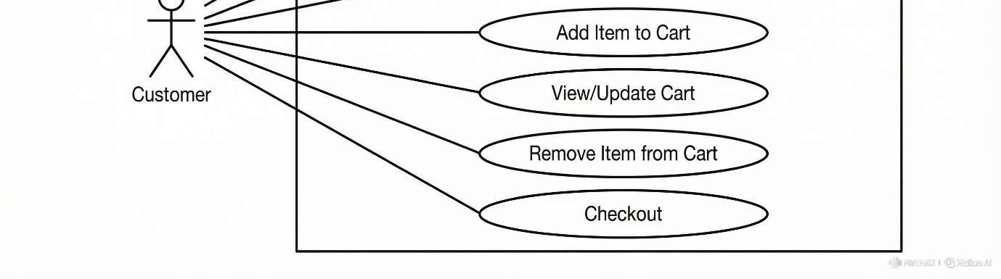

Data Flow Diagram (DFD)
Entities & Flows:
- Customer → STYLE US Web App: browse/search/select items, add to cart
- STYLE US Web App → Customer: product listings, cart summary, notifications
Note: Since the application is client-side only, the DFD focuses on browserbased flows rather than server interactions.
Diagram placeholder (image):
- Insert DFD Level 0 image here. DFD Level 1 (Detailed Flows)
Processes:
- Display Products — Retrieves product data from client-side JS object and renders the product grid.
- Search Processing — Accepts search query, matches products, and returns filtered results.
- Cart Management — Handles add/update/remove operations and saves cart state to LocalStorage.
- Product Details Rendering — Reads query parameters and displays product-specific information.
Data Stores:
- D1 – Product Catalog: JavaScript object/array in client script. • D2 – Cart Store: Browser LocalStorage (key: cart).
External Entity: Customer (browser user)
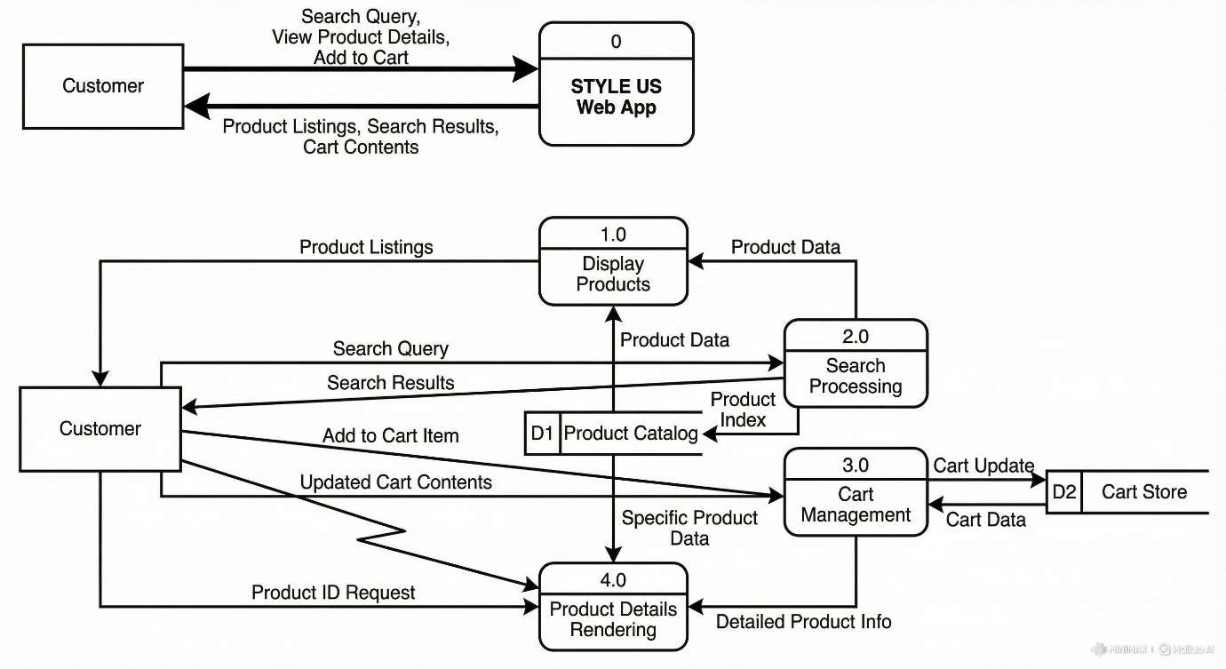

ER Diagram (Conceptual)
Although the project does not use a server-side relational database, a conceptual ER diagram helps visualize data entities for future expansion.
Entities & Attributes (Conceptual):
- Product (productId, name, description, price, imgUrl, categoryId)
- Category (categoryId, categoryName)
- CartItem (cartItemId, productId, quantity, price)
Relationships:
- Product belongs to Category (Many-to-One)
- CartItem references Product (Many CartItems → One Product)
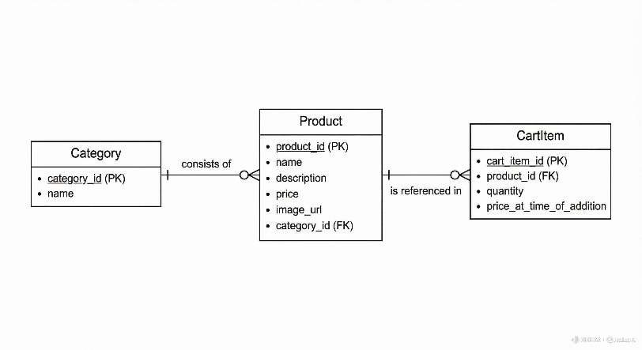

Screenshots
Screenshots to include:
- Home / Category Navigation (sidebar + header)
- Product Listing (Men's T-Shirts category)
- Product Detail page (example product)
- Search Results page (sample query)
- Cart page / Cart count badge updated
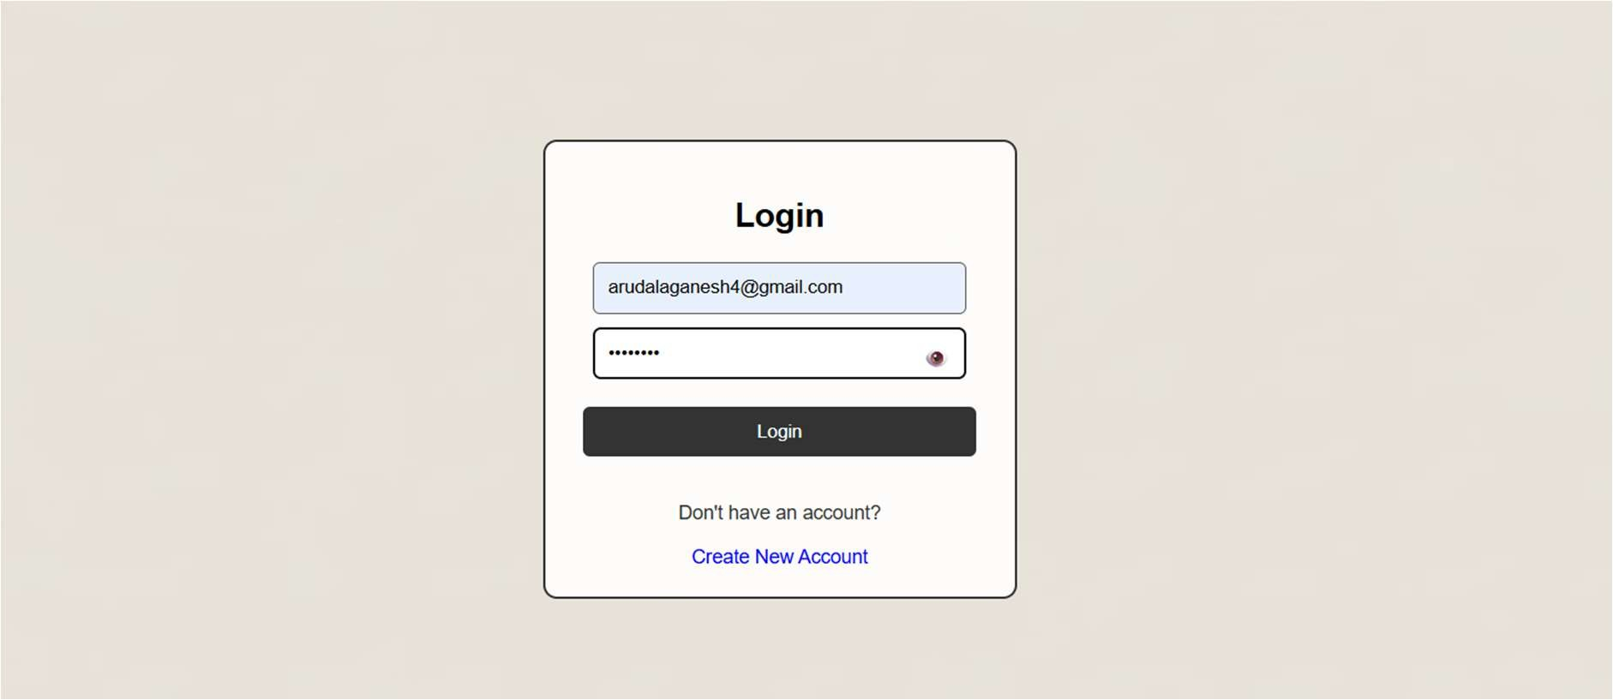

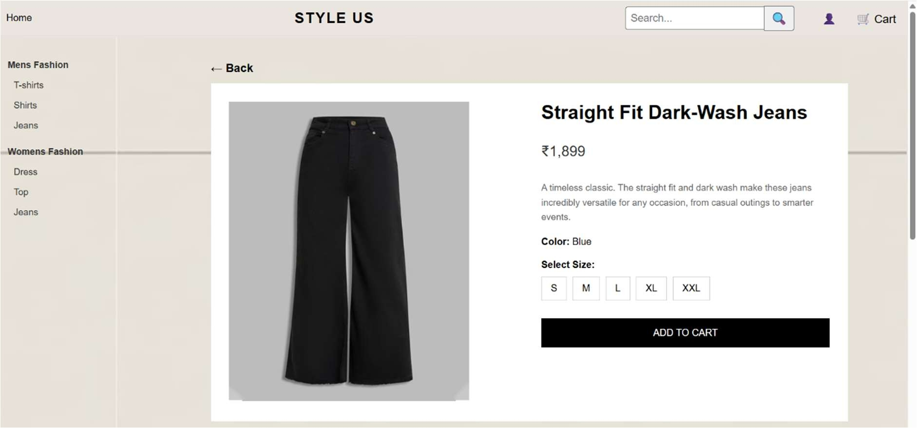
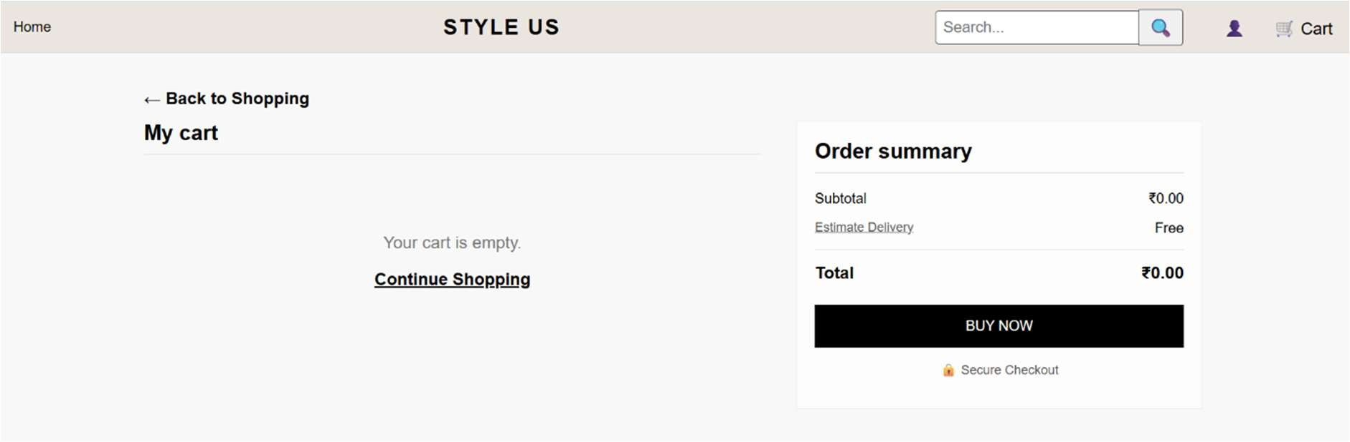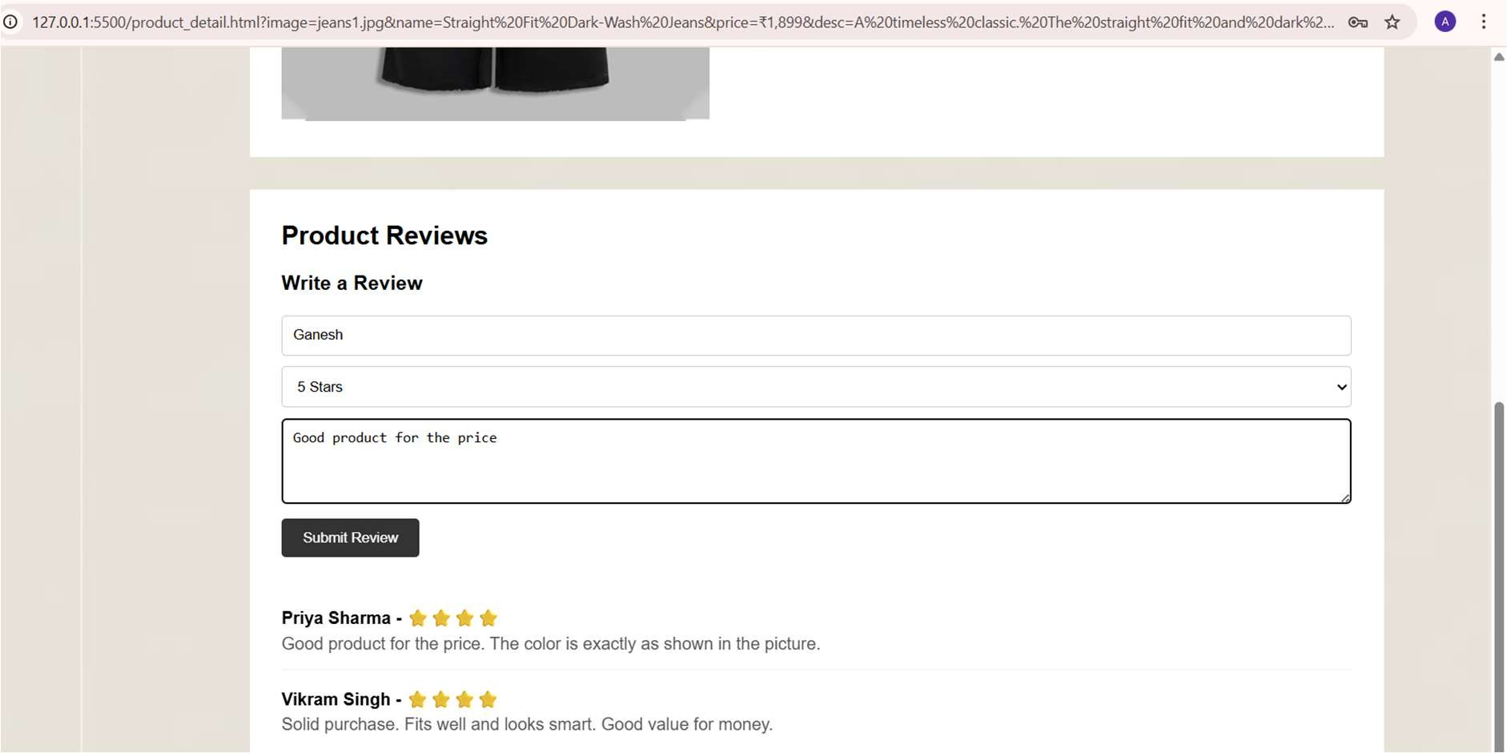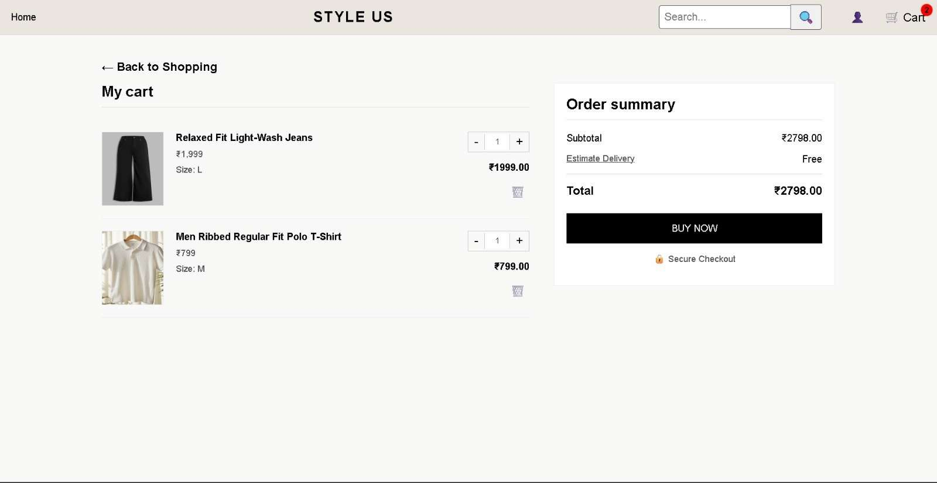

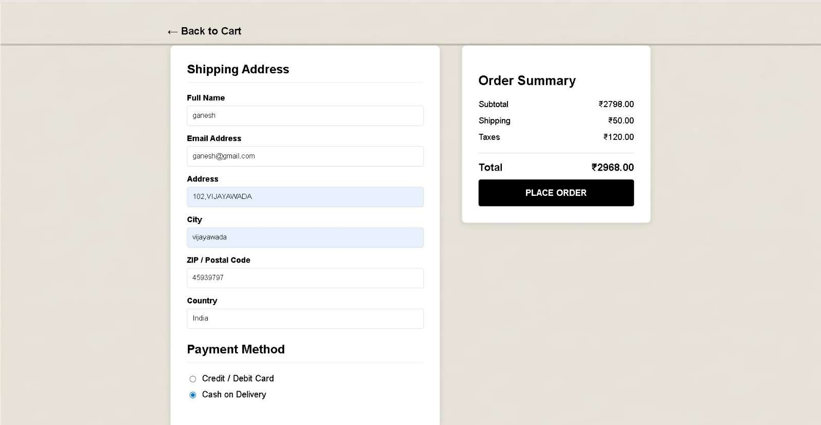

Limitations
- No backend server or database — data persistence beyond browser storage is not available.
- LocalStorage is device/browser specific and not shared across devices.
- No user authentication system or secure payment integration implemented.
- Scalability constraints for large product catalogs without pagination or server-side support.
- Minimal accessibility and internationalization features.

Future Enhancements
- Integrate a backend (Node.js / Django / PHP) with a database (MySQL / MongoDB) to store products, users, and orders.
- Implement user authentication and profile management.
- Add payment gateway integration (Razorpay / PayPal / Stripe).
- Implement admin panel for product CRUD operations and inventory management.
- Add advanced search with filters (price range, size, color) and pagination.
- Improve accessibility (ARIA attributes) and responsive breakpoints for various devices.
- Add analytics tracking and order history for users.

Conclusion
The STYLE US project provides a practical demonstration of building a clientside e-commerce web application using HTML, CSS, and JavaScript with LocalStorage for cart persistence. It showcases key e-commerce functionalities such as category-wise product display, search, product details, and cart management in a compact, easy-to-understand prototype. This internship project helped in understanding front-end development workflows and provided handson experience in implementing user interactions and state persistence in the browser.

